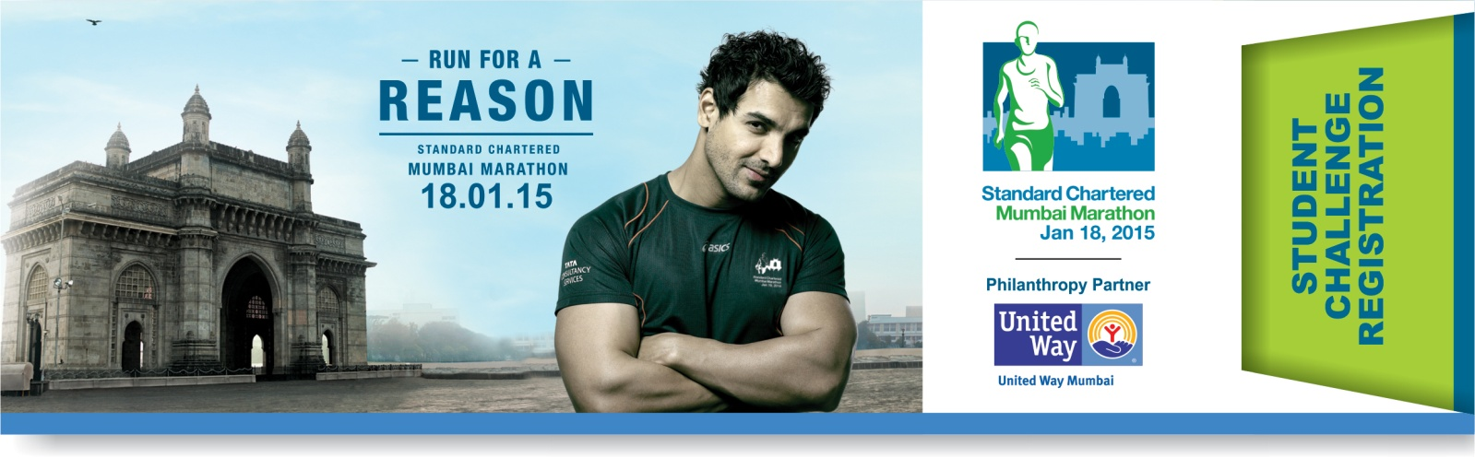

NAME OF THE INSTITUTE:

ADDRESS:

OFFICE LANDLINE #:WEBSITE:

COORDINATOR | NAME | EMAIL ID | MOBILE #
STUDENT
INSTITUTE STAFF

SUPPORTED CHARITY:

The donation amount per team of 5 students is INR 50,000. This could be one cheque or multiple cheques that could total to INR 50,000. All cheques should be in favour of United Way of Mumbai. Please fill the details of the cheques below.
Sr. # | Donor’s Name | Amount | Cheque # | Dated | Bank Name | Bank branch details | 80G receipt in the name of | Donor’s address | PAN # of donor
1
2
3
4
5
6
7
8
9
10
 | TOTAL

INSTITUTE SEAL:

TERMS AND CONDITIONS:
- Irrespective of how many people donate, only 5 bonafide students of the present academic year 2014- 2015 can participate for the registration amount of INR 50,000.
- Once registered, the Institute cannot withdraw its registration. The donation amount is neither refundable nor transferable to any other category/institute.
- Post registration, for every INR 10,000 raised, the Student Challenge team will get one additional bib. This bib can be availed by other students over the age of 12, teachers, staff, alumni and supporters of the Institute.
- The Student Challenge participants can participate only in the Dream Run.
- Every Student Challenge team can avail of a maximum of 15 bibs (Inclusive of the 5 Bibs that they get during registration).
- The Institute can request for a second team initially of 5 students at INR 50,000 if they have raised INR 150,000 for the first team of 15 by 29 September 2014. A team may be given subject to availability of running slots.
- The student coordinator will be our point of contact for all communications. In absence of the student coordinator, UWM will get in touch with the Staff coordinator of the institute as mentioned above.
- The Institute will have a Student Challenge fundraising page with a donate button that they can share and urge people to donate. There would be one page per team.
- The student coordinator and the staff coordinator will be given a login id and password to the team registration page where they can keep tab of the donations.
- United Way of Mumbai absorbs the payment gateway charges for all online donations. No donations are retained for online donations.
- United Way of Mumbai would retain 2% of all offline (cheque/draft) donations.
- The institute needs to specify the charity for which you intend to donate the proceeds of the registration amount. The online donations will be directed to the chosen nonprofit through United Way of Mumbai.
- The average amount per bib per institute will be taken into consideration for priority line up in SCMM 2016.

Please note, this payment is a donation and therefore no TDS needs to be deducted. An 80 G receipt will be issued to the donor for donations of INR 100 and above.

- The list of NGOs who register for the SCMM 2015 with United Way of Mumbai will be available on our website-www.unitedwaymumbai.org/marathon and also in the online registration page that will be created for your team.
  - Regular newsletters and updates to all team participants.
  - Institution specific Online Giving Page facility on our website for online fund raising.
  - Orientation for your students on raising funds (on request).
  - Reconciliation of funds collected.
  - Issuing 80 G receipts to every donor and individual.
  - Acknowledging your team on our website along with team page.
  - Acknowledgement in the Charity Docket published after the event.

- If your institute comes under FCRA regulations, please note that your designated supported charity partner must have FCRA permission.

- All terms & conditions for participation in the Standard Chartered Mumbai Marathon 2015 as indicated on www.scmm.procamrunning.in shall also apply to Student Challenge participants.

- Participation in the event is subject to confirmation of application of each participant. The race organizer’s decision in this regard is final & binding.

- Race Application fees payable by each team will depend upon the race category each team member will opt for.

- All contributions above INR 100 are eligible for 80G tax exemption receipt.

- Your application is not transferable or refundable.

Checklist: The Institute needs to be registered as an educational institute under the (Indian) Societies Registration Act 1860, its amendments, that validate the authenticity of the body as a recognized educational institution.
The photocopy of this document needs to be attested by the Head of the Institution.

HEAD OF THE INSTITUTE:

SIGNATURE:

NAME:

DESIGNATION:

DATE:

PAN # OF THE INSTITUTE
Attach photocopy of PAN Card:

INSTITUTE SEAL:

CONTACT US:

United Way of Mumbai
309, Nirman Kendra, Famous Studio Lane, Dr. E Moses Rd, Mahalaxmi Estate, Mumbai 400011, India.

Tel: 00 91 22 24937676/86 Helpline No.: 9029080123

E-mail:learn@unitedwaymumbai.org

Checklist:
- The Institute needs to be registered as an educational institute under the (Indian) Societies Registration Act 1860, its amendments that validate the authenticity of the body as a recognized educational institution. Please attach a photocopy of this document attested by the institution head.
- One Cheque of INR 50,000/- or Multiple Cheques totalling to INR 50,000/- in favour of United Way of Mumbai
- PAN card photocopy of the Institute
- Duly filled Student Challenge registration form.

Website:www.unitedwaymumbai.org

FREQUENTLY ASKED QUESTIONS:

Eligibility criteria
The Institute needs to be registered as an educational institute under the(Indian) Societies Registration Act 1860, its amendments that validate the authenticity of the body as a recognized educational institution.

The list of documents that need to be attached
- The photocopy of the registration of the institute registered under the Indian Societies Regulation Act 1860, its amendments, attested by the head of the institution with the institute seal.
- The duly filled Student Challenge form.
- One cheque of INR 50,000 OR multiple cheques totalling to INR 50,000, details of which need to be duly filled in the Student Challenge form. The cheques should be in favour of “United Way of Mumbai”.
- The photocopy of the PAN card of the Institute.

Team Constitution
Once an Institute registers with INR 50,000 they are eligible for 5 Bibs for Bonafide Students who have enrolled for a course in the institute as on 18 January 2015. For every INR 10,000 raised thereafter they could avail of one additional bib, to a maximum of 15 bibs per team. The bibs after the first 5 Student Bibs could be given to students, alumni, staff, trustees or friends and families of the institute.

Second Team Booking
The Institute can request for a second team initially of 5 students at INR 50,000 if they have raised INR 150,000 for the first team of 15 by 29 September 2014. Second team will be allocated basis availability of running places. All rules of Student Challenge shall be applicable to the 2nd team requested and allocated.

Run Category
Student Challenge participants are eligible only for the Dream Run.

