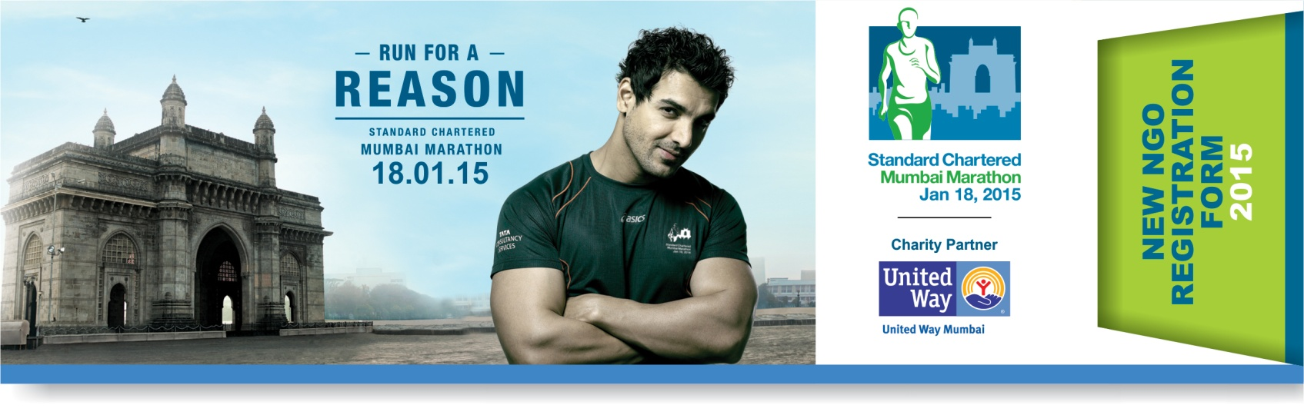

IMPORTANT NOTES TO BE READ BEFORE COMPLETING THE FORM.

- This form should be completed by any organization seeking registration for SCMM 2015, as a listed NGO with United Way of Mumbai.
- Please send across the softcopy of your duly filled NGO Registration Form along with the softcopy of your logo in printable vector file format (.cdr, or .eps) to scmm@unitedwaymumbai.org (we require this for creating your Online Giving Page and all publicity material, where relevant)
- Please attach a copy of your duly filled NGO registration form with a cheque of Rs 2500/- in favour of “United Way of Mumbai” and send it to United Way of Mumbai, 309,Nirman Kendra, Famous studio lane, Dr. E. Moses Road, Mahalaxmi- 400011.
- Please register your organization on our charity community. This will help you to increase your fund raising ability and to stay updated with latest communication related to SCMM 2015.
Follow this link http://www.unitedwaymumbai.org/charity_community.htm

Name of NGO :
(This name will reflect on your online giving page and charity docket)
Acronym (if any)

Date of Incorporation
Organizational Address:  (Please include City, State & Pincode) | Correspondence Address |  |  | Registered Address
Name of Director/Chairperson
Director/Chairperson’s Email id |  |  |  | Mobile #: | +91
Landline # of NGO
 | NGO website address | YouTube page link | Facebook page link |  |  | Twitter page link
Online Details
Contact Person details | Name | Designation | Mobile # |  |  | Email id
Contact Person 1

Contact Person 2

Contact Person 3

Have you registered previously with the SCMM? | First Time | SCMM 2014* | SCMM 2013 | SCMM 2012 | SCMM 2011 | SCMM 2010  *This form has to be filled by those who haven’t participated in SCMM 2014 or have raised less than Rs. 10,000/- at SCMM 2014.
Beneficiary Group  Note: Please highlight only one category closest to your primary cause. Your online page will be listed under the same | Education | Environment | Disability | Arts, Culture & Sports | Health |  Livelihood Generation | Women Empowerment | Animal Welfare | Gender Equality | Social, Civic & Community Development | Children | Elderly Care  If Others, please specify:- ____________________________________________________

BANKING INFORMATION (MANDATORY):
IMPORTANT- Please ensure these details are accurate since disbursements will be made through direct transfer.

 | Domestic Account Details | FCRA Account Details
- Bank Name
- Bank Account Number
- Bank Account Holder Name
- Bank Branch Name
- Bank Branch Code
- Bank Account Type (Saving/Current)
- IFSC Code
- Bank Address

ANNEXURE I
Share a two line description about your NGO. This will be displayed on your online page on our website (maximum 50 words)

ANNEXURE II

Brief write up about your organization and area of intervention. This information will be displayed on your online page & used for the purpose of any publicity during SCMM 2015 (maximum 200 words).

ANNEXURE III

Brief Summary of your appeal for support with details of where and how you intend to spend funds raised by donor’s support (maximum 200 words)

SUPPORTING DOCUMENTS REQUIRED:

All NGO's require to submit copies of the below listed documents (all photocopies must be self-attested by CEO/ Director of the NGO). Soft copy of this filled form and logo to be sent to scmm@unitedwaymumbai.org

Please Note: The following documents are required to be submitted along with the NGO registration form.

CHECKLIST:

- Copy of Certificate of registration of the NGO (Societies Registration Act 1860 / Public Trust Act / Section 25-Company's Act)
- Copy of 12A registration certificate under the income tax
- Copy of 80 G Certificate / Application for renewal
- Copy of FCRA registration certificate (if applicable) front and back
- Copy of PAN Card.
- Address Proof such as electricity or telephone bill.
- Latest audited annual accounts including auditor's report (2013-2014; 2012-2013; 2011-2012).
- Mumbai payable cheque/DD for Rs. 2,500/- favoring “United Way of Mumbai”.
- Soft copy of your logo preferably in printable vector format (cdr/eps, etc.) or if unavailable in highest .jpeg resolution. Your logo will be used for your online page as well as any event related communication by Procam.
- One cancelled Cheque of Domestic/FCRA account as applicable. These are required for validation purpose.

TERMS & CONDITIONS: (IMPORTANT)

  - Registration with United Way of Mumbai, the official Charity Partner, as a ‘Listed NGO’ for the Standard Chartered Mumbai Marathon 2015 is subject to submission of documents as required in the NGO Registration document, confirmation of the same, and realization of payment of INR 2500/- as annual registration charges.
  - The listed NGO shall be solely responsible for the information provided by it in this registration form. Information so provided by listed NGO's in this application will be showcased on the event website and in other mediums for the sole purpose of promoting the respective Listed NGO and/or the Event.
  - You will be required to submit information to United Way of Mumbai on utilization of the funds raised through the Standard Chartered Mumbai Marathon 2015.
  - Listed NGO's shall raise funds through the Event using the Charity Structure specifically devised for the 2015 edition of the Event. Where funds are raised using modes other than those included in the said Charity Structure, such modes will be subject to written confirmation from the official charity partner.
  - All funds raised through the Event must be reported to the official charity partner. Listed NGO's not reporting to United Way of Mumbai, may not be able to register themselves as beneficiary NGO's in the 2016 edition of the Event. UWM has full right to debar any NGO not adhering to the same.
  - Listed NGO's receiving/expecting donations from outside India or from companies having more than 51% foreign holdings must have a valid FCRA permission.
  - Funds received from donors, companies and other entities, will be remitted to listed NGO's in phases, after deducting processing charges, wherever applicable and as is mentioned in the Charity Structure. Any discrepancies in the amount received must be brought to the notice of United Way of Mumbai immediately.
  - Decisions with respect to all aspects of the Event shall rest solely with the Promoters, Procam International.
  - Registration with United Way of Mumbai for Standard Chartered Mumbai Marathon 2015 is limited to funds raised through this Event.

DISCLAIMER:

We confirm that we have fully read and understood the terms and conditions outlined herein and the Event Rules and Regulations as given in event website www.procamrunning.in/scmm and agree to abide by the same.

Name

NGO Stamp
Designation

Date

Signature

