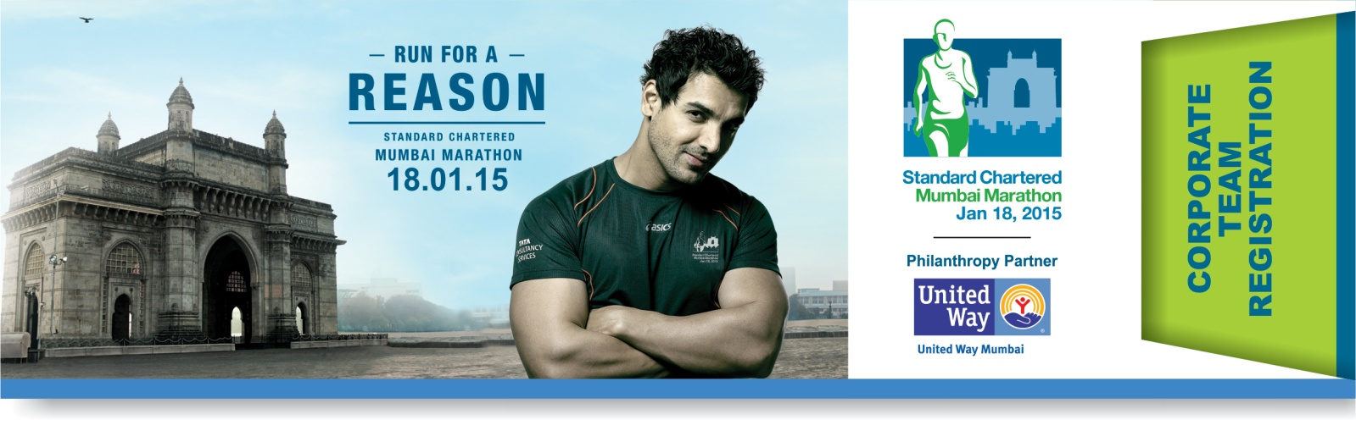

**NAME OF THE COMPANY:**

**BUSINESS SECTOR:**

**ADDRESS:**

**OFFICE LANDLINE #: WEBSITE:**

|  |  |  |  |  |
| --- | --- | --- | --- | --- |
| **SR. #** | **CONTACT PERSON NAME** | **DESIGNATION** | **EMAIL ID** | **MOBILE #** |
| **1.** |  |  |  |  |
| **2.** |  |  |  |  |

**80G RECEIPT IN THE NAME OF:**

**PAN # OF COMPANY:**

**SUPPORTED CHARITY:**

**NO OF TEAMS:** Team 25 X Team 15 X

**MODE OF DONATION** (*Please refer to terms & conditions*)

* 

Single Cheque Donation to UWM OR Split Cheque

* 

**UWM Cheque #: Dated: Amount:**

**\*NGO Cheque#: Dated: Amount:**

*(*Applicable only if split cheque option selected)*

***Note: *If 51 % or more of the Company Share Holdings are foreign held then the contribution is deemed as FCRA and comes under the Foreign contributions regulations act. Beneficiary charities need to have an FCRA certification to receive such funds. Company has to provide copy of share holding pattern along with this registration.***

**As per above, does your Company falls under FCRA? Yes / No**. **COMPANY SEAL:**

**TERMS AND CONDITIONS:**

* Your company registers by filling up this Corporate Team registration form and making a donation amount as may be applicable.
* Once the Corporate is registered, it cannot back out of the registration. The donation amount is neither refundable nor transferable to any other category.
* A corporate can register a maximum of 7 teams
* You need to specify the charity(s) for which you intend to donate the proceeds of the registration amount. In case your company has not decided the charity yet, please leave the section blank. The charity can be added later while registering the team online.

**Team: 25: INR 4,00,000 (Maximum 25 runners can run for any race category) X number of teams**

**Team: 15: INR 2,75,000 (Maximum 15 runners can run for any race category) X number of teams**

**Donation contribution can be made in either of 2 ways:**

**1. Single Cheque Donation:** Entire Amount should be in favour of UNITED WAY OF MUMBAI as per team size. The donation amount includes donation to United Way of Mumbai of INR 35,000 (Team 25) / INR 25,000 (Team 15) which United Way of Mumbai will retain to defray administrative expenses incurred towards the charity aspect of SCMM 2015. The selected charity receives the balance amount post **deduction of actual race application fees** as per race category chosen by individual team members.

An 80 G receipt will be issued to the company on the full registration donation amount by United Way.

**2. Split Cheque: For companies participating through their CSR budget as per the new companies act.**

* For Team 25 - (i) **INR 3,40,000** in favour of chosen **NGO**, (ii) **INR 60,000** in favour of **United Way of Mumbai**. The **INR 60,000** cheque will include entry fees for individual team members and UWM’s donation retention for which UWM will issue an 80G receipt
* For Team 15 – (i) **INR 2,35,000** in favour of chosen **NGO**, (ii) **INR 40,000** in favour of **United Way of Mumbai**. The **INR 40,000** cheque will include entry fees for individual team members and UWM’s donation retention for which UWM will issue an 80G receipt.

***Note: Need to submit both the cheques along with this form & we will hand over the cheque to the NGO.***

***Please note, this payment is a donation and therefore no TDS needs to be deducted. An 80 G receipt will be issued to the company on the registration donation amount.***

* The list of NGOs who register for the SCMM 2015 with United Way of Mumbai will be available on our website - [www.unitedwaymumbai.org/marathon](http://www.unitedwaymumbai.org/marathon) and also in the online registration page that will be created for your team.
* Team registering for corporate challenge is eligible for the following in SCMM’15.
  + Special separate holding area and tent for corporate team participants
  + Corporate team participants can select any race category of their choice. We strongly recommend marathon and half marathon runners submit their timing certificate of any past running event which has been conducted not earlier than 18 months prior to 18 January 2015, along with their application (details available on [www.scmm.procamrunning.in](http://www.scmm.procamrunning.in). Runners submitting timing certificate will get priority line-up at the start of marathon/half marathon race based on the finish time mentioned on respective certificates.
  + Regular newsletters and updates to all team participants.
  + Corporate team members bibs will carry “corporate team’ on it.
  + Corporate specific Online Giving Page facility on our website for online fund raising.
  + Orientation for your employees on raising funds (on request).
  + Reconciliation of funds collected.
  + Disbursing funds, including matching contributions to the charity of your corporate’s choice.
  + Issuing 80 G certificates to every donor, corporate and individual.
  + Priority privileges for teams qualifying under corporate challenge within corporate team.
  + Acknowledging your team on our website along with team page.
  + Acknowledgement in the Charity Docket published after the event.
* If your corporate comes under FCRA regulations, please note that your designated supported charity partner must have FCRA permission. Also while registering you will be required to submit your company shareholder pattern while registering without which our bank will not clear the payment.
* All terms & conditions for participation in the Standard Chartered Mumbai Marathon 2015 as indicated on [www.scmm.procamrunning.in](http://www.scmm.procamrunning.in) shall also apply to Corporate Team participation.
* Participation in the event is subject to confirmation of application of each participant. The race organizer’s decision in this regard is final & binding.
* Race Application fees payable by each team will depend upon the race category each team member will opt for.
* All contributions are eligible for 80G tax exemption receipt.
* Your application is not transferable.

**AUTHORIZED SIGNATORY (NAME):**

**DESIGNATION:**

**SIGNATURE:** ________________________

**DATE:**

**COMPANY SEAL:**

**CONTACT US:**

United Way of Mumbai

309, Nirman Kendra, Famous Studio Lane, Dr. E Moses Rd, Mahalaxmi Estate, Mumbai 400011, India.

**Tel:** 00 91 22 24937676/86 Helpline No.: 09029080123

**E-mail:** [corporate@unitedwaymumbai.org](mailto:corporate@unitedwaymumbai.org)

**Website:** www.unitedwaymumbai.org